***Report – Coursera – Gym or Yoga Studio***

***Introduction***

***Business Problem***

* ***The business problem is basically answering the question of where should I invest my savings opening a Gym.***
* ***The general feeling is that people that practice Yoga are "fitness junkies" and therefore practice both Yoga and Gym if they have the chance.***
* ***Wherever there is a Yoga Studio, there is a market for a Gym***
* ***I will analyze this in my region to find the BEST LOCATION to open Gym***

***Data***

***I will collect data from the different Yoga Studios and Gyms in the regions around my house.***

***And I will check whether there is any place where we have a Yoga Studio but not a Gym around.***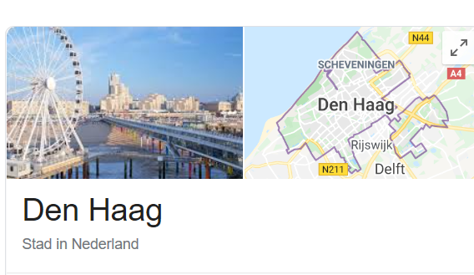

Using visual representation of both gyms and yoga studios from FourSquare

The map shows the Yoga Studios in blue and the Gyms in green

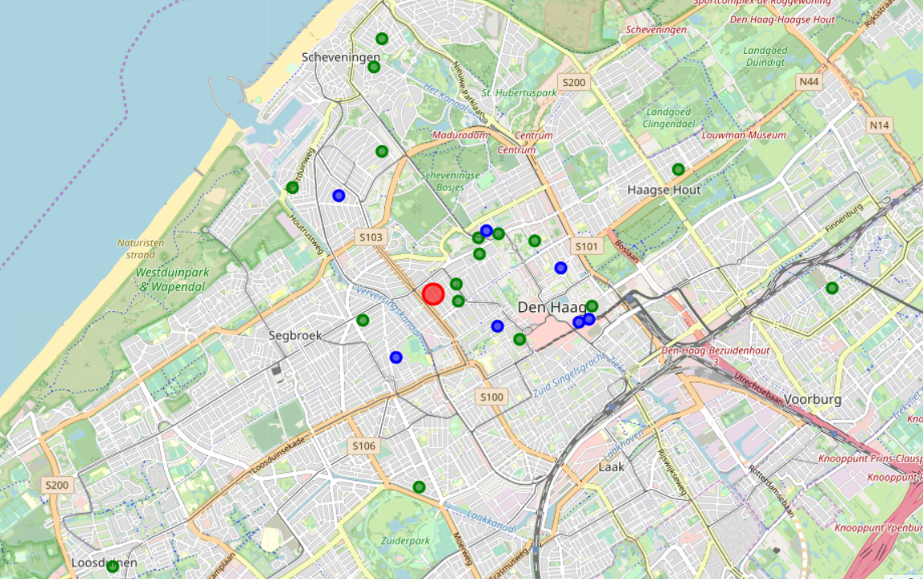

Given this situation we will clusterize by distance (latitude and longitude) to see the proximity of Gyms and Yoga Stuidos and if there are Yoga Studios with no Gyms around. Those are our business opportunities

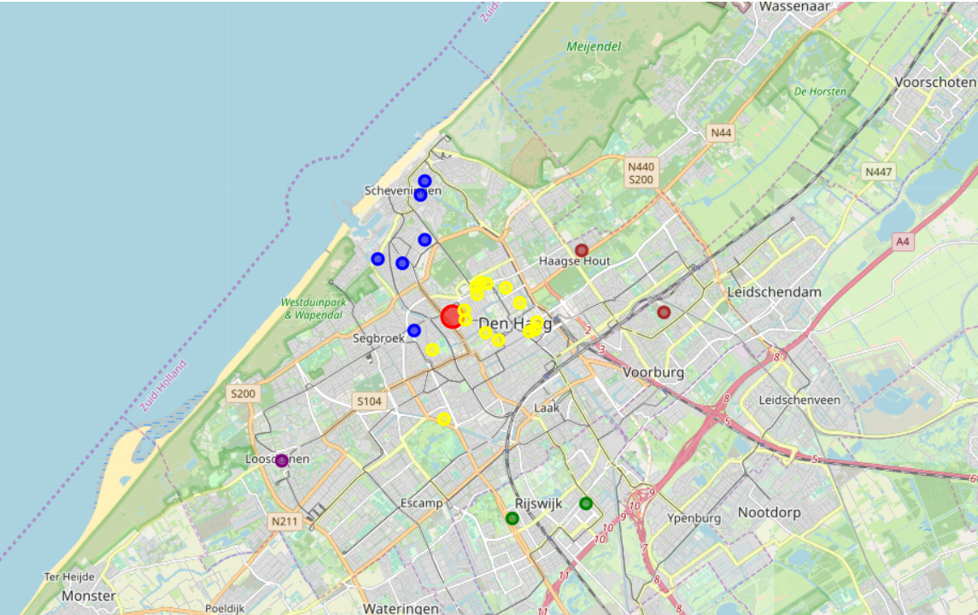

The map is clearly clustering the areas by neighborhoods:

* Cluster 0 is Sergbroek and Scheveningen
* Cluster 1 is City Centre
* Cluster 2 is Leidschendam and Haagse Hout
* Cluster 3 is Rijkskwijk
* Cluster 4 is Loosdouinen

***Analytical testing to form a more solid conclusion***

If we put together the graphical clusterization with the number of Gyms and Yoga Studio we see 3 areas of opportunity. They are coincidentally the areas that are further away from the centre of the city

|  |  |  |
| --- | --- | --- |
| **Cluster** | **# of Yoga Studios** | **# of Gyms** |
| Sergbroek and Scheveningen | 5 | 1 |
| City Centre | 9 | 6 |
| Leidschendam and Haagse Hout | 2 | 0 |
| Rijkskwijk | 2 | 0 |
| Loosdouinen | 1 | 0 |

***Results***

*We can clearly see in the second map that close to my house (marked in red) in the City Centre Neighborhood there is a strong correlation between Yoga studios In the table above we see there are gyms and Yoga Studios (6 and 9 respectively)  
In the area of Sergebroek and Scheveningen there are also Gyms and Yoga Studios (5 and 1 respectively)*

*However, the areas farther away like Rijkskwik (cluster 3 -green) and Loosduinen (cluster 4 - purple) have only Gyms (2 and 1 as per table above)*

*By using economic studies like price of houses and tax info we know that the area of Rijswijk has a high economic power has a Yoga studio but not Gym.*

***Discussion***

*Seeing the results above expressed, my recommendation is to open a Gym in Rijkswik  
Conclusion section where you conclude the report.  
I would invest in a Yoga studio in the area of Rijkswijk*

***Conclusion***

*I would invest in a Yoga studio in the area of Rijkswijk*

Discussion

Seeing the results above expressed, my recommendation is to open a Gym in Rijkswik  
**Conclusion section where you conclude the report.**I would invest in a Yoga studio in the area of Rijkswijk

I would invest in a Yoga studio in the area of Rijkswijk

Conclusion